MLOPS

# Using Designer

We are going to build restaurant ratingsnased on the restaurants dataset. Available in samples.

## Step 1: Create Compute Instance

## Step 2: Data Wrangling and Data Transformation

Select "Designer" from the left menu. Choose the "Classic Prebuilt" tab and then click the + sign to create a new pipeline.

### Dataset

1. Add the sample datasets, **Restaurant Ratings** and **Restaurant Feature Data**, to the pipeline canvas.
2. Add Select Columns in Dataset for **Restaurant Ratings**  and **Restaurant Feature Data**.
3. Double click on Select Columns in Dataset

* 1. Select placeID and rating from the **Restaurant Ratings** data source.

* 1. Select placeID, alcohol, dress_code, price, and Rambience from the **Restaurant Feature Data** source.

Output

### Transformation

1. Join the data sources using placeID as key.

Double click on Join Data, add placeID for columns and select Left Outer Join as the Join Type. Set False for the Keep Right Key Columns in joined table

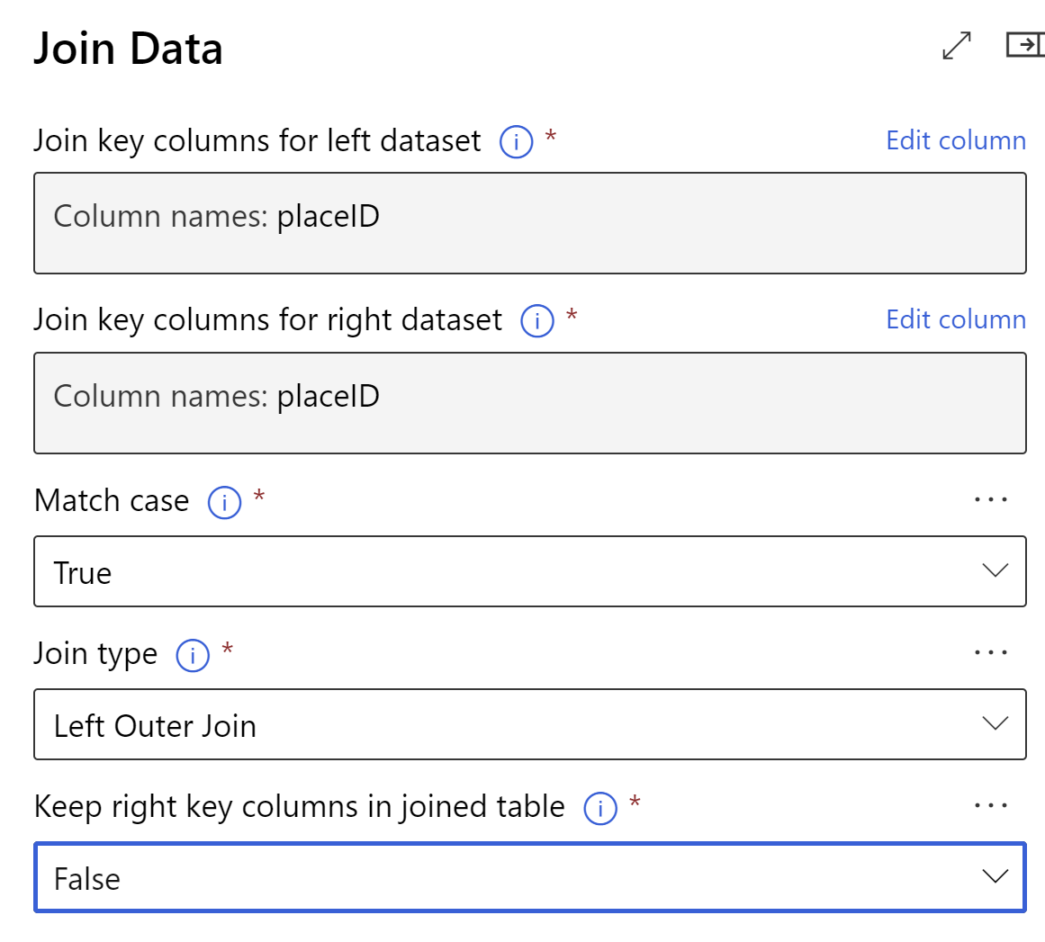

1. Replace missing data in columns (placeID, rating, alcohol, dress_code, price, Rambience) with *0*.

### Submit the pipeline

Give the experiment name

Select the compute

Hit Submit to create a new pipeline job

Navigate to Jobs

Check for Outputs + Logs

You can look at the output data as well once the job is complete.

The results are ultimately stored in the Azure Blob Store container.

### Clean the data

Add all the columns to cleanup any missing data

## Step 3: Split Data & Train the Model

1. Connect the Cleaned Dataset from Clean Missing Data to Split Data

1. Split data using a 60/40 split.

* + 60% should go to a filter using Pearson correlation
  + 40% should be used as test

### Feature Selection

1. Create a Pearson correlation Feature selection using **rating** as a target column (select columns to transform and apply transformation).

Select Columns to Transform

Apply Transformations

### Model Training

1. Create a Boosted Decision Tree Regression with the following settings:
   * Create trainer mode: SingleParameter
   * Maximum number of leaves per tree: *20*
   * Minimum number of leaves per tree: *10*
   * Learning rate: *0.2*
   * Total number of trees constructed: *100*

1. Create Train Model using rating as label column.

## Step 4: Scoring and Evaluate

1. Create Score Model activity.

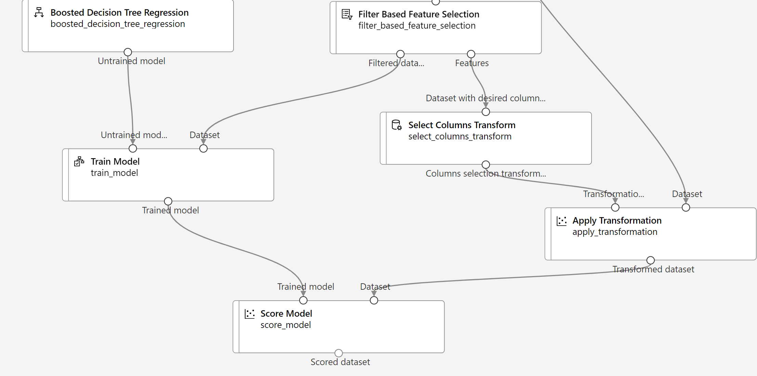

1. Create Evaluate Model activity.

1. Submit Model.
2. Evaluate Results.

Improvements can be made further.

## Step 5: Register the Model Registry

1. Navigate to the Jobs and get the latest experiment run.
2. Select train model
3. Look at Outputs + Logs and get the model type

1. Now, click on the Register model.

1. Get the trained model outputs

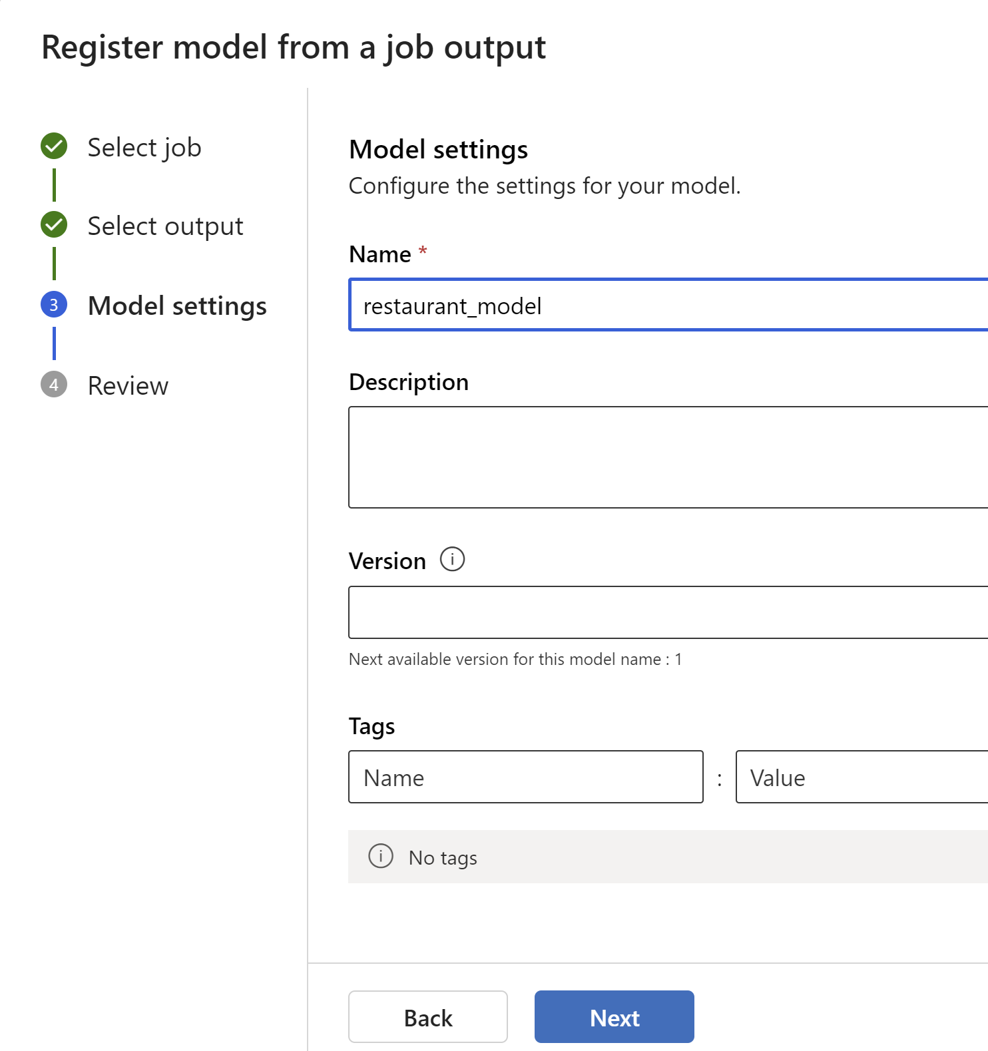

## Step 6: Deploy Endpoint

1. Create a compute cluster

1. Download conda and score.py files
2. Create a custom environment

Copy conda file contents

After creation,

Navigate to Model List, and select the model that you have recently created.

Review & then Create.

Create a batch scoring job

Next step is to move the model from Dev to QA.

# Using ML Notebooks

References: Download templates from here: <https://github.com/Azure/mlops-templates>

Download the relevant code base from here: <https://github.com/Azure/mlops-project-template/tree/main/classical>

## Step 1: Configure your environment

1. If you do not have an existing environment, use Terraforms to create a new one. infrastructure\terraform\github-actions\tf-gha-deploy-infra.yml
2. Set your config-infra-dev.yml & config-infra-prod.yml
3. Run your mlops\github-actions\deploy-model-training-pipeline-classical.yml

